

Issue Management Process©
For [Project Name]

Document Control

Document Information
© | Information
Document Id | [Document Management System #]
Document Owner | [Owner Name]
Issue Date | [Date]
Last Saved Date | [Date]
File Name | [Name]

Document History
Version | Issue Date | Changes
[1.0] | [Date] | [Section, Page(s) and Text Revised]

Document Approvals
Role | Name© | Signature | Date
Project Sponsor

Project Review Group

Project Manager©

Quality Manager
(if applicable)

Procurement Manager
(if applicable)

Communications Manager
(if applicable)

Project Office Manager
(if applicable)

Table of Contents

Template Guide 1
1 Issue Process 2
1.1 Overview 2
1.2 Raise Issue 4
1.3 Register Issue 4
1.4 Assign Issue Actions 4
1.5 Implement Issue Actions 4
2 Issue Roles 5
2.1 Issue Originator 5
2.2 Project Manager 5
2.3 Project Review Group 5
2.4 Project Team 5
3 Issue Documents 6
3.1 Issue Register 6
3.2 Issue Form 6

Template Guide

What is an Issue Management Process?

An Issue Management Process is a method by which issues which are currently affecting the ability of the project to produce the required deliverables are formally managed. The process entails completing a variety of review techniques to assess the level of impact that the issue is having on the project and then undertaking a range of actions to resolve or reduce the issue as appropriate.

The Issue Management Process is used to ensure that every issue identified is formally:

- Communicated
- Documented
- Monitored
- Reviewed
- Resolved. ©

When to use an Issue Management Process

Although the Issue Management Process is undertaken during the ‘Execution’ phase of the project (i.e. the phase within which the deliverables are produced), project issues may be identified at any stage of the project lifecycle. In theory, any issue identified during the life of the project will need to be formally managed as part of the Issue Management Process. Without a formal Issue Management Process in place, the objective of delivering a solution within ‘time, cost and quality’ may be compromised.

The Issue Management Process is terminated only when the Execution phase of the project is completed (i.e. just prior to Project Closure). ©

How to use this template
This document provides a guide on the topics usually included in an Issue Management Process. Sections may be added, removed or redefined at your leisure to meet your particular business circumstance. Example tables, diagrams and charts have been added (where suitable) to provide further guidance on how to complete each relevant section.

Issue Process

Overview
Provide an overview of the Issue Management Process. For example:

"The Issue Management Process is undertaken to ensure that each issue identified within the project environment is documented, prioritized and resolved within an appropriate timescale. For the purpose of this project, an issue is defined as any event which currently adversely affects the ability of the project to produce the required deliverables." ©

Issue Management will be introduced to this project through the implementation of five key processes:

- The identification of project issues
- The logging and prioritization of project issues
- The determination of issue resolution actions
- The monitoring and control of assigned issue resolution actions
- The closure of project issues.

The following diagram describes the processes and procedures to be undertaken to identify, document, priorities and resolve issues within the project. Where applicable, Issue Roles have also been identified:

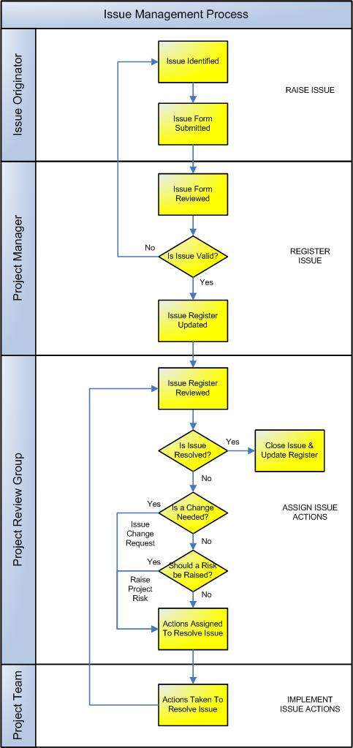

Raise Issue
This process provides the ability for any member of the project team to raise a project-related issue. The following procedures are undertaken:

Issue Originator

- Identifies an issue applicable to a particular aspect of the project (e.g. scope, deliverables, timescales)
- Completes an Issue Form and forwards it to the Project Manager. ©

Register Issue
The Project Manager reviews the issues raised and determines whether or not each issue is applicable to the project. This decision is based upon whether or not the issue impacts on:

- A deliverable specified in the Deliverables Register
- The quality targets specified in the Quality Plan
- The delivery targets specified in the Project Plan
- The resource targets specified in the Resource Plan
- The financial targets specified in the Financial Plan.

If the issue is considered by the Project Manager to be ‘related to the project’, then a formal issue is raised in the Issue Register and an issue number assigned. The Project Manager will assign an issue ‘priority’ based upon the level of impact of the issue to the project.

Assign Issue Actions
The Project Review Group formally review each issue listed in the Issue Register (based upon issue priority) and may decide:

- To close the issue in the Issue Register if there are no outstanding issue actions and the issue is no longer impacting on the project
- To raise a change request if the issue results in the need for a change to the project
- To raise a project risk if the issue is likely to impact on the project in the future
- To assign issue actions to attempt to resolve the issue. ©

Implement Issue Actions
The actions assigned by the Project Review Group are then implemented. This entails:

- Scheduling each action for completion
- Implementing each action scheduled
- Reviewing the success of each action completed
- Communicating the success of each action completed.

Issue Roles

Define the roles and responsibilities for all resources (both internal and external to the project) involved with the identification, review and resolution of issues within the project. An example follows.

Issue Originator
The Issue Originator identifies the issue and formally communicates the issue to the Project Manager. The Issue Originator is responsible for:

- The formal documentation of the issue by completing an Issue Form
- The submission of the Issue Form to the Project Manager for review.

Project Manager
The Project Manager receives, records, monitors and controls the progress of all issues within a project. The Project Manager is responsible for:

- Receiving Issue Forms and identifying whether the issues are appropriate to the project
- Recording issues deemed appropriate to the project in the Issue Register
- Prioritizing issues in the Issue Register and initiating the Project Review Group meeting
- Reporting and communicating all decisions made by the Project Review Group. ©

Project Review Group
The Project Review Group undertakes an assessment of the issue and assigns issue resolution actions where appropriate. The Project Review Group is responsible for:

- Regularly reviewing all issues recorded in the Issue Register
- Identifying issues which require change requests and/or project risks to be raised
- Approving issue resolution actions
- Closing issues which are no longer impacting on the project.

Project Team
The Project Team undertake all issue resolution actions delegated by the Project Review Group.

Issue Documents

List any other documentation used to monitor and/or control issues within the project.

Issue Register
The ‘Issue Register’ is the log / database where all issues are registered and tracked through to resolution. Insert a template for the Issue Register here to show how issues will be monitored and tracked on this project. (NB Refer to the Method123 ‘Issue Register' for a complete example).

Issue Form
The ‘Issue Form’ is used to identify and describe an issue in the project. Insert a template for the Issue Form here, to show how issues will be documented and raised on this project (NB Refer to the Method123 ‘Issue Form’ for a complete example).

